Task1

MADL

Syeda Shehar Bano

SP20-bcs-049

Task

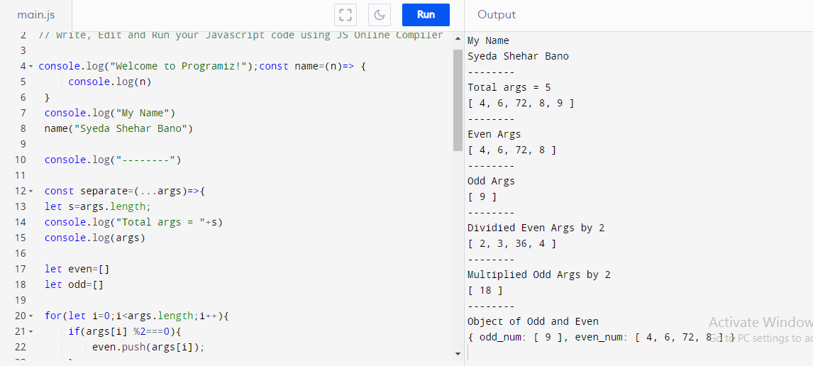

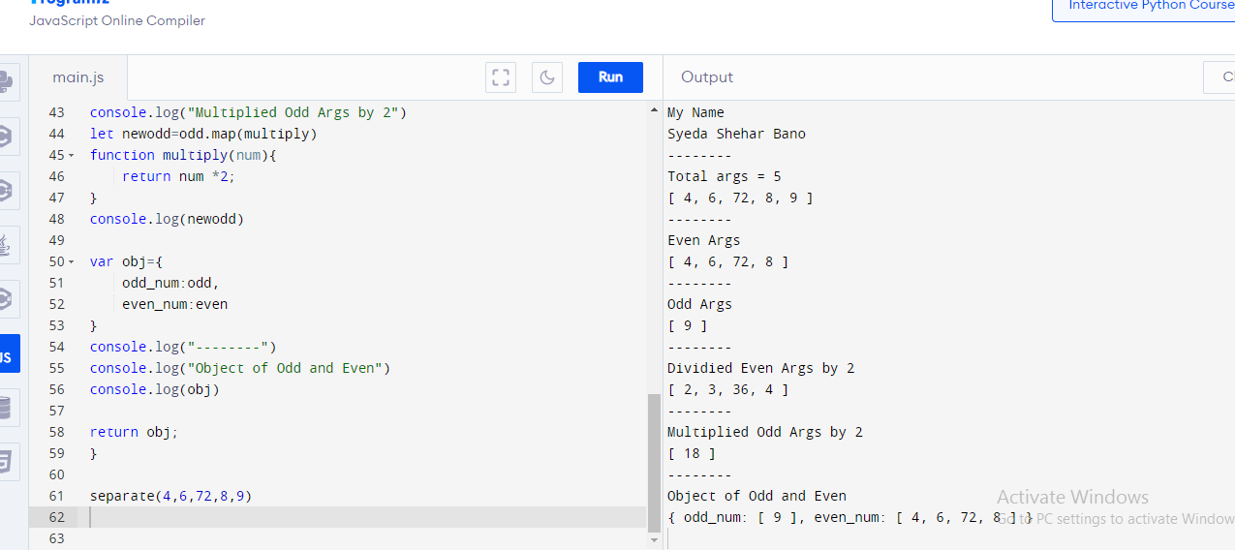

end